Camouflage
Yellowstone National Park
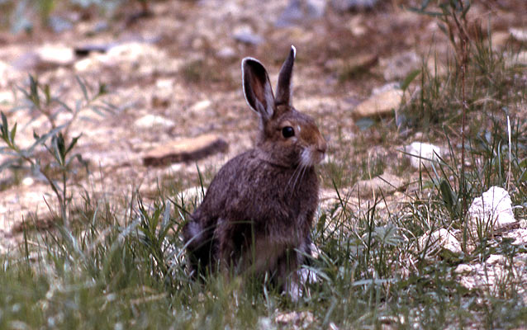
Snowshoe hare. BHB

SUBJECT:
Biology: Animals, Ecology, Physical Education, Physical Fitness, Wildlife Biology
DURATION:
20 minutes or longer
GROUP SIZE:
Up to 36
SETTING:
indoors
NATIONAL/STATE STANDARDS:
Next generation science standards: 3-LS4-2., 3-LS4-3., MS-LS4-4.
KEYWORDS:
adaptation, animals, camouflage, ecology, physical education, Physical Fitness, predator, prey, wildlife biology

Overview
This active game may be used to introduce the concepts of predator prey dynamics as well as adaptations.

Objective(s)
Students role play predator or prey to learn about physical/behavioral adaptations in predation.

Background
All organisms have adaptations that help them survive and thrive. Some adaptations are structural. Structural adaptations are physical features of an organism like the bill on a bird or the fur on a bear. Other adaptations are behavioral. Behavioral adaptations are the things organisms do to survive. For example, bird calls and migration are behavioral adaptations.
Structural or physical adaptations usually occur because a gene mutates or changes by accident. Some mutations can help an animal or plant survive better than others in the species without the mutation.
For example, imagine a bird species. One day a bird is born with a beak that is longer than the beak of other birds in the species. The longer beak helps the bird catch more food. Because the bird can catch more food, it is healthier than the other birds, lives longer and breeds more. The bird passes the gene for a longer beak on to its offspring. They also live longer and have more offspring, and the gene continues to be inherited generation after generation.
Eventually the longer beak can be found in all of the species. This doesn't happen overnight. It takes thousands of years for a mutation to be found in an entire species.
Over time, animals that are better adapted to their environment survive and breed. Animals that are not well adapted to an environment may not survive.
The characteristics that help a species survive in an environment are passed on to future generations. Those characteristics that don't help the species survive slowly disappear.

Procedure
- Enter into a discussion about adaptations: definition, types. Elicit from students examples of physical and behavioral adaptations.
- Outline an area with boundaries. If you have adults with you, they can stand at the corners of the boundaries, or use packs/rocks, etc, to designate boundaries.
- Choose one student to be the 'prey'.
- All other students are the 'predators'.
- The 'prey' student stands in one place, back to the playing field. He/she counts to 20 (loudly and slowly: 1-1000, 2-1000 and so on).
- The 'predators' go out to hide.
- When the 'prey' reaches 20, he/she turns around and looks for 'predators'. He/she can stand on tiptoes, bend, squat but not move his/her feet.
- The teacher walks out into the field. If the 'prey' spots a 'predator', he/she directs the teacher to where the 'predator' is. If there is a 'predator' there, the teacher taps the 'predator' and he/she is out. The 'predator' is out and sits off to the side. Give the 'prey' a few moments to look. Do not let the looking go on too long. When finished, have the 'prey' turn his/her back again and begin counting again, this time only to 10. While the 'prey' counts, the 'predators' try to get closer to the 'prey', hiding before he/she reaches 10.
- Repeat number 8.
- Give the 'prey' a few moments to look. Do not let the looking go on too long. When finished, have the 'prey' turn his/her back and begin counting again, this time only to 5.
- While the 'prey' counts, the 'predators' run in, trying to tag the prey before he/she reaches 5. The first to tag the 'prey' becomes 'prey' for the next game.
- At the end of the game, gather players around and ask what they did that was helpful. Elicit behaviors as well as clothing. Relate these ideas to behavioral/physical adaptations.
- Ask students what they would change if they could play again.
- Play the game again.
Helpful Hints
- When giving directions, be very clear about how high the 'prey' counts each time. Repeat these directions during the game.
- Be very specific about the boundaries, reminding students that they don't want to get too far away.
- Limit the looking time to 2-3 minutes unless the 'prey' is locating 'predators'. If the looking goes on too long, the game drags and 'predators' become impatient.
- Avoid allowing the 'prey' to call out names. If 'prey' is allowed to call out names, the 'prey' could just call names of students they know are out in the field without actually seeing them.
- Tell the 'predators' that they have 2 goals: to remain hidden so as not to be caught, and to get close enough to the 'prey' to be able to run in and tag him/her the final time.
- Play the game 2-4 times. The first time, students will forget the rules. By the second time, they have a much better idea of how to manage themselves so as not to be caught.

Assessment
What did you do that helped? Was that a structural (physical) or behavioral adaptation?
What did you do that got you caught? Was that a structural (physical) or behavioral adaptation?
Are you wearing anything that helps or hurts?
Why do you think ________ tagged the ‘prey’ first?
What if you could play again? Would you do anything differently?

Park Connections
Yellowstone is home to many species of animals both predator and prey who rely on their adaptations such as camouflage for survival.

Extensions
Conduct a science experiment based on camouflage. Select several habitats in the area. Have students develop a procedure and write hypothesis about which habitat will result in the most predators being spotted after the first count, what color clothing is most likely to be spotted, or another question students choose.
Research camouflage and other adaptations utilized by animals in Yellowstone or near your school.

